**Week 03-01**

**--Coding-C-Language-Features-Optional.**

**Roll no**: 241801326

**Name**: Yogeetha. A

**To find the day of year number for a standard date, scan down the Jan column to find the day of month, then scan across to the appropriate month column and read the day of year number. Reverse the process to find the standard date for a given day of year.**

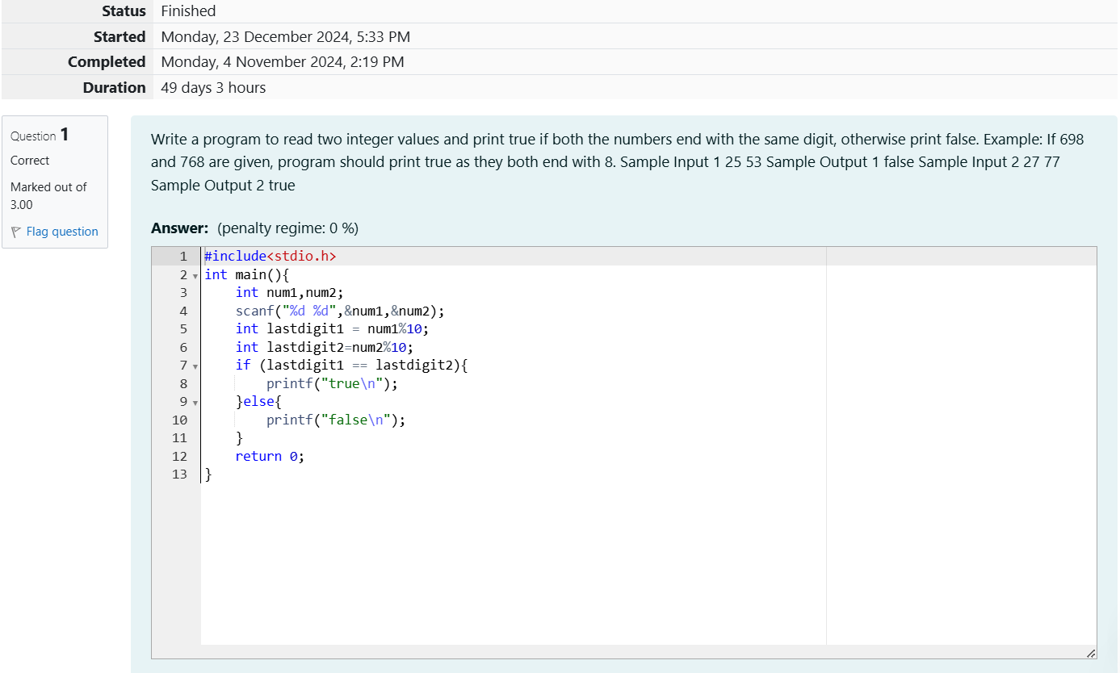

**OUTPUT:**

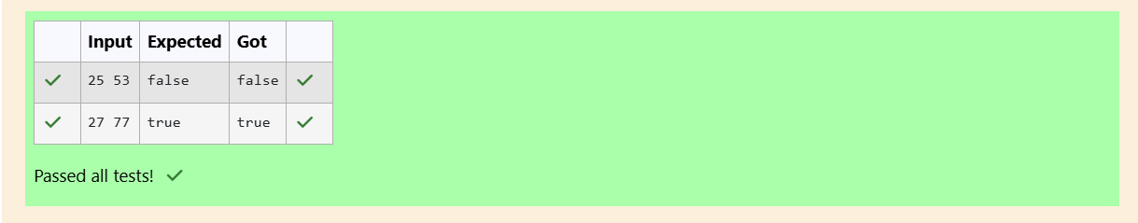

**To print ‘Weird’ if the number is odd, even when number ranges from 6 to 20,and print ‘Not weird’ when the number is even and ranges from 2 to 5 and greater than 20.**

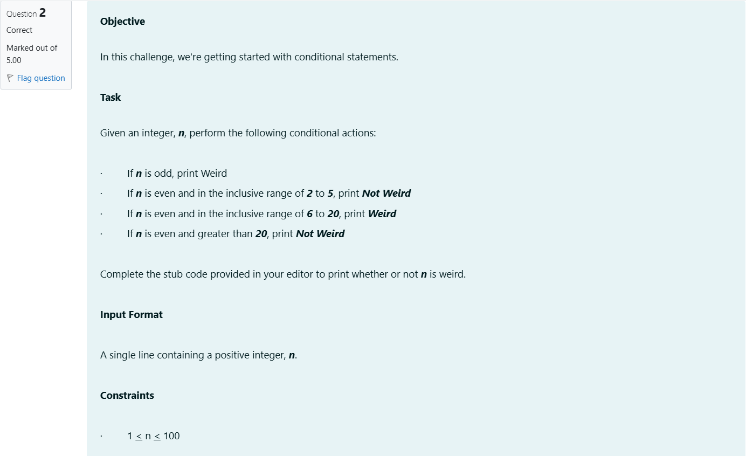

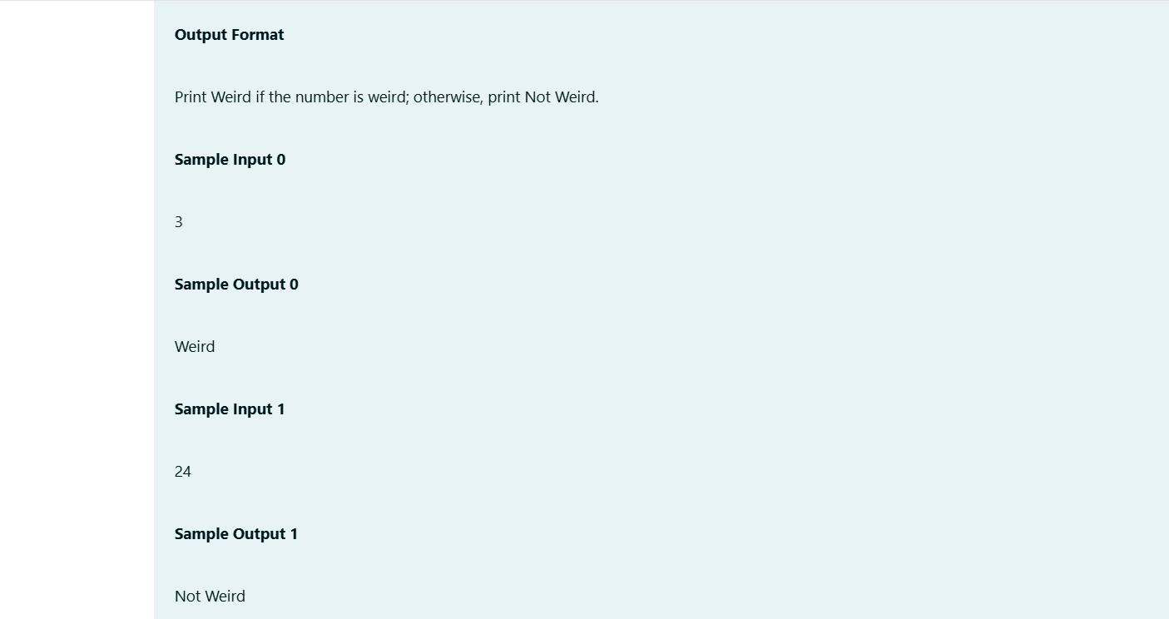

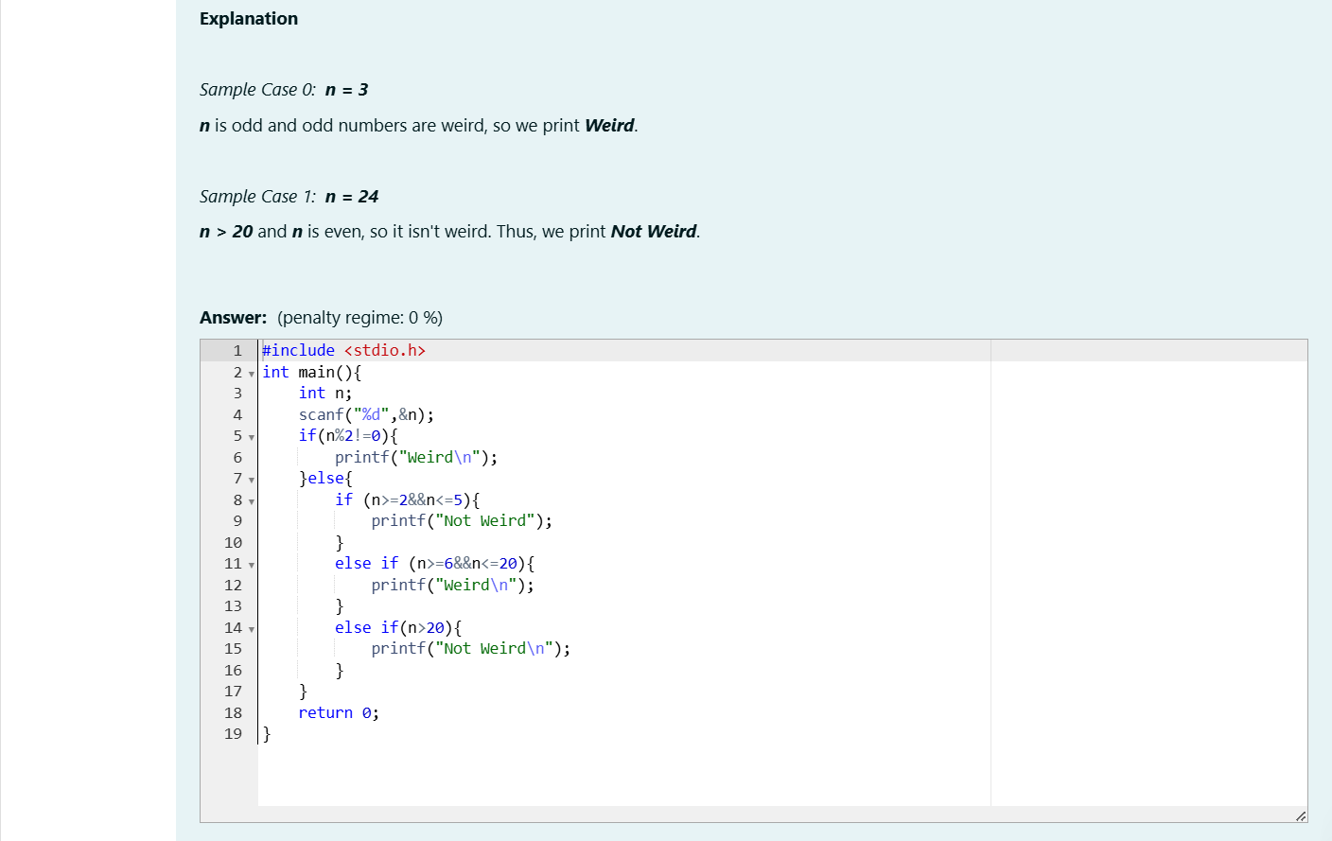

**OUPUT:**

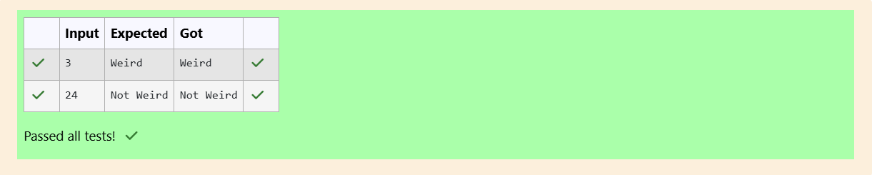

**To check the whether the three sides of the triangle are Pythagoras trio or not.**

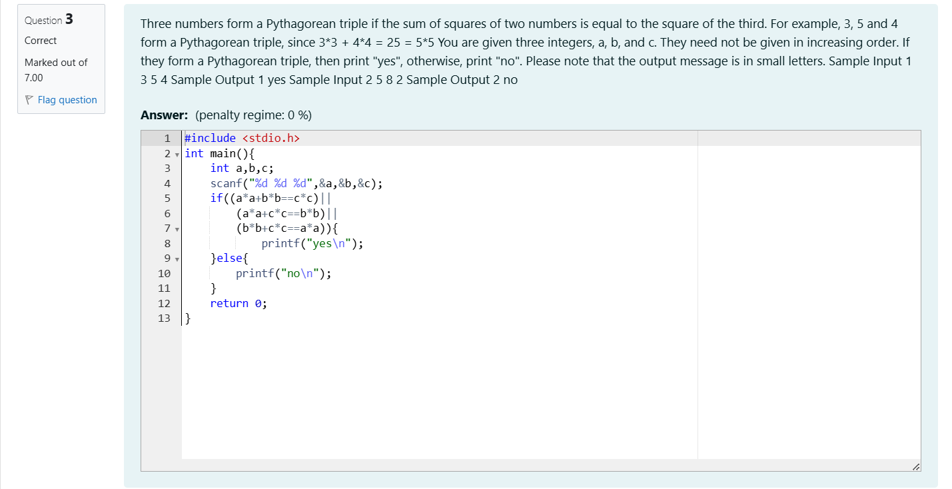

**OUTPUT:  
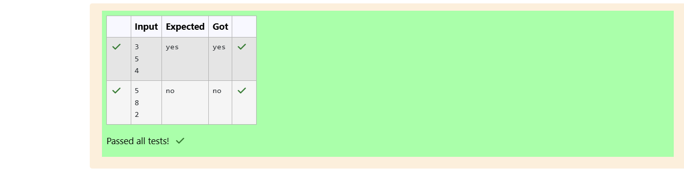**

**Week 03-02**

**Roll no: 241801326**

**Name: Yogeetha A**

**To identify the shapes with the given number of sides.**



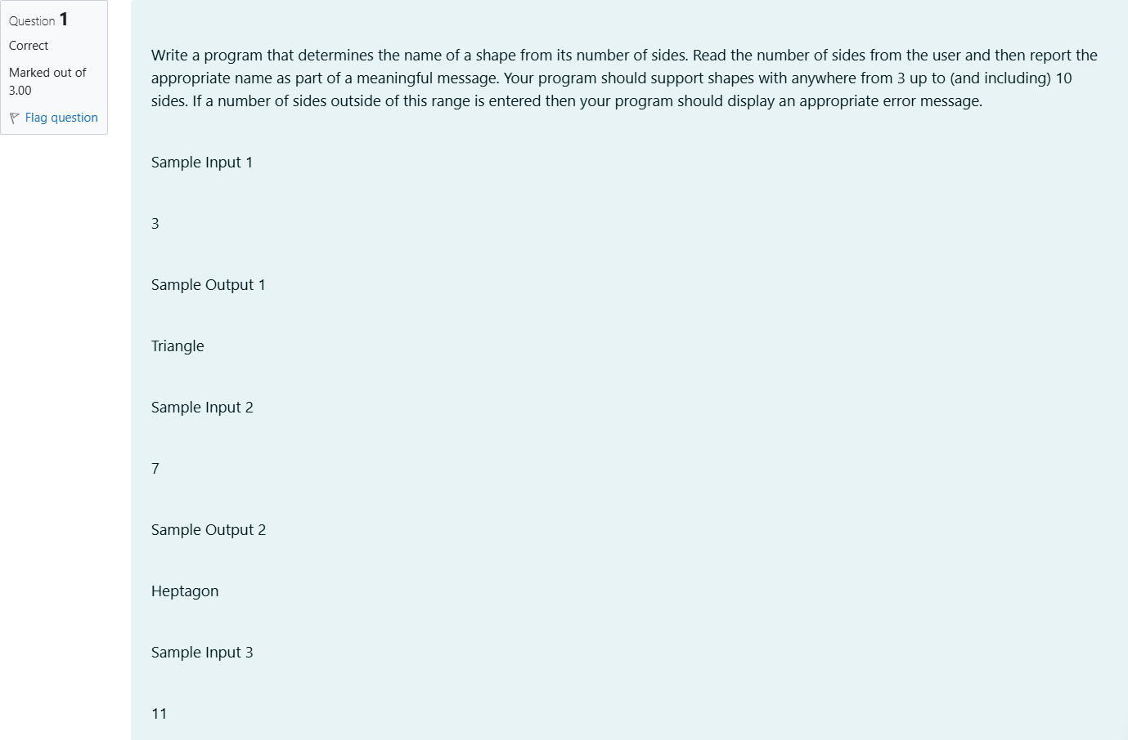

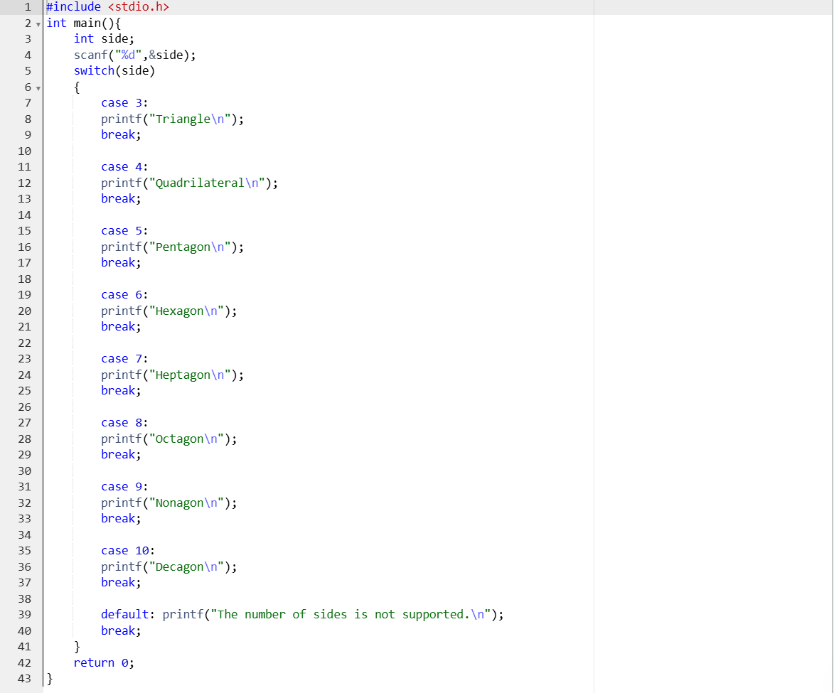

**OUTPUT:**

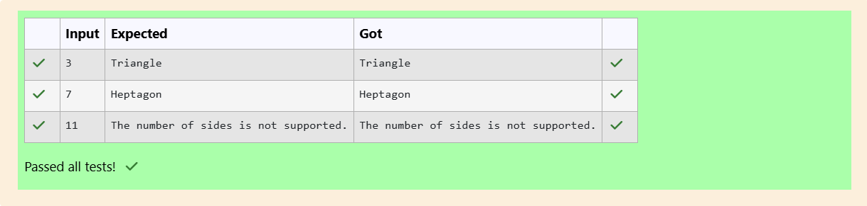

**Print the Chinese zodiac assigns to years in a 12 year cycle.**

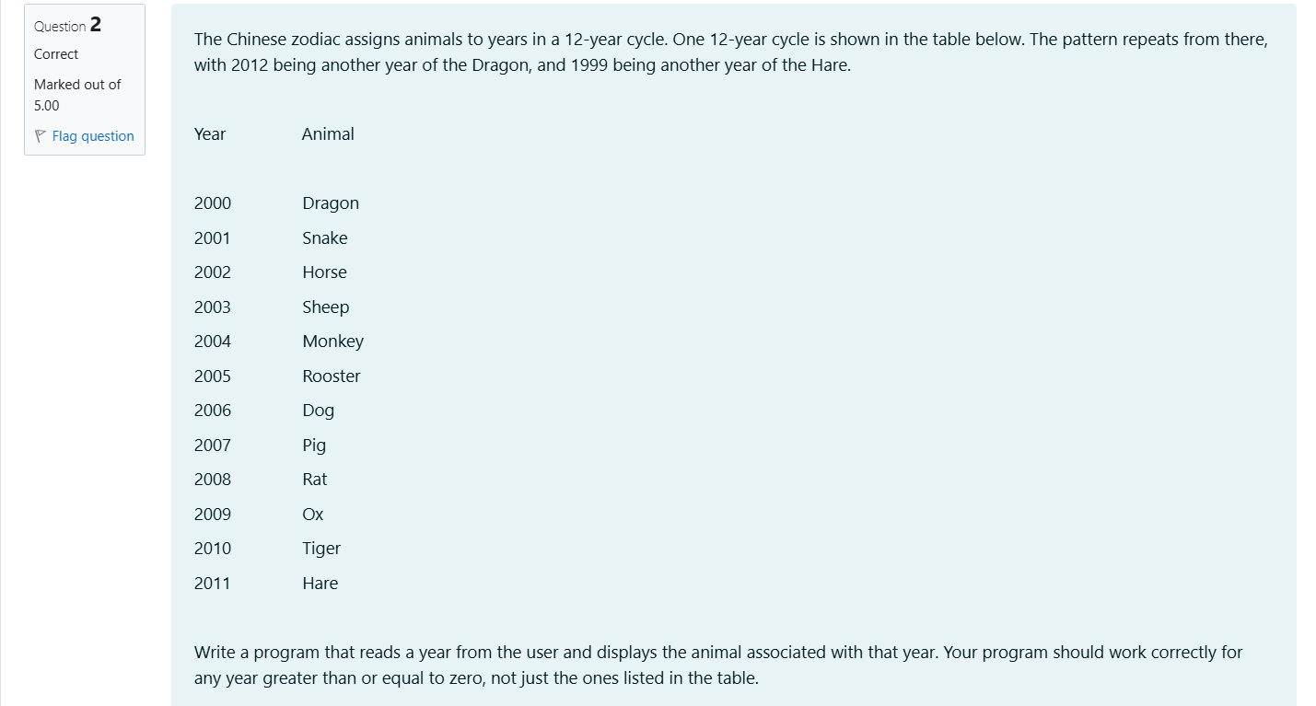

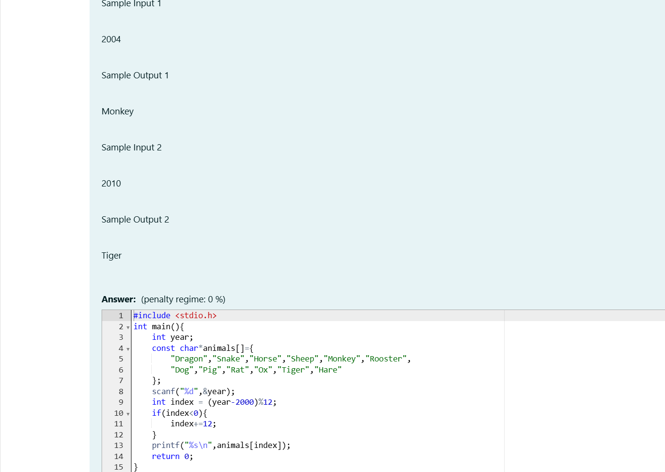

**OUTPUT:**

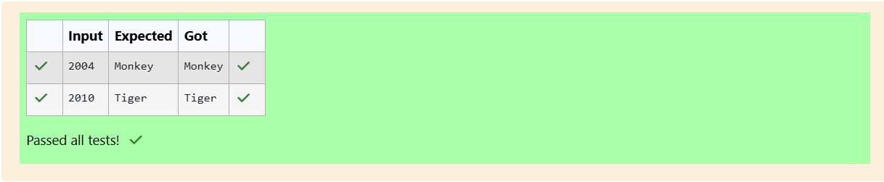

**To determine whether the column begins with black square or white square**

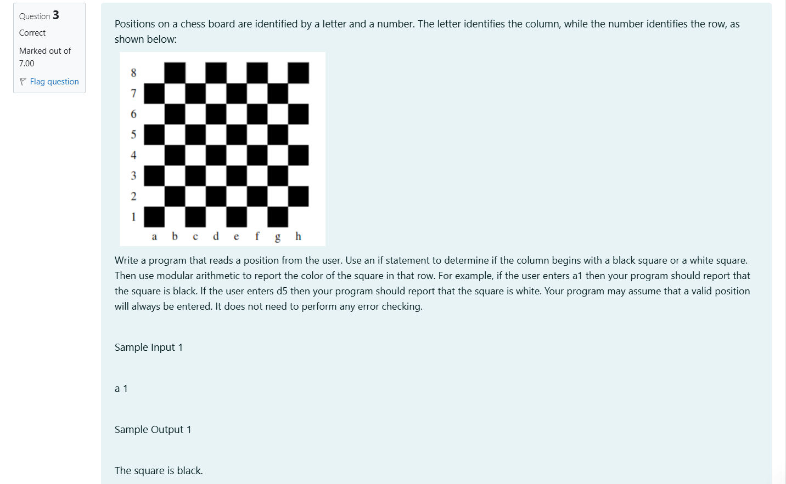

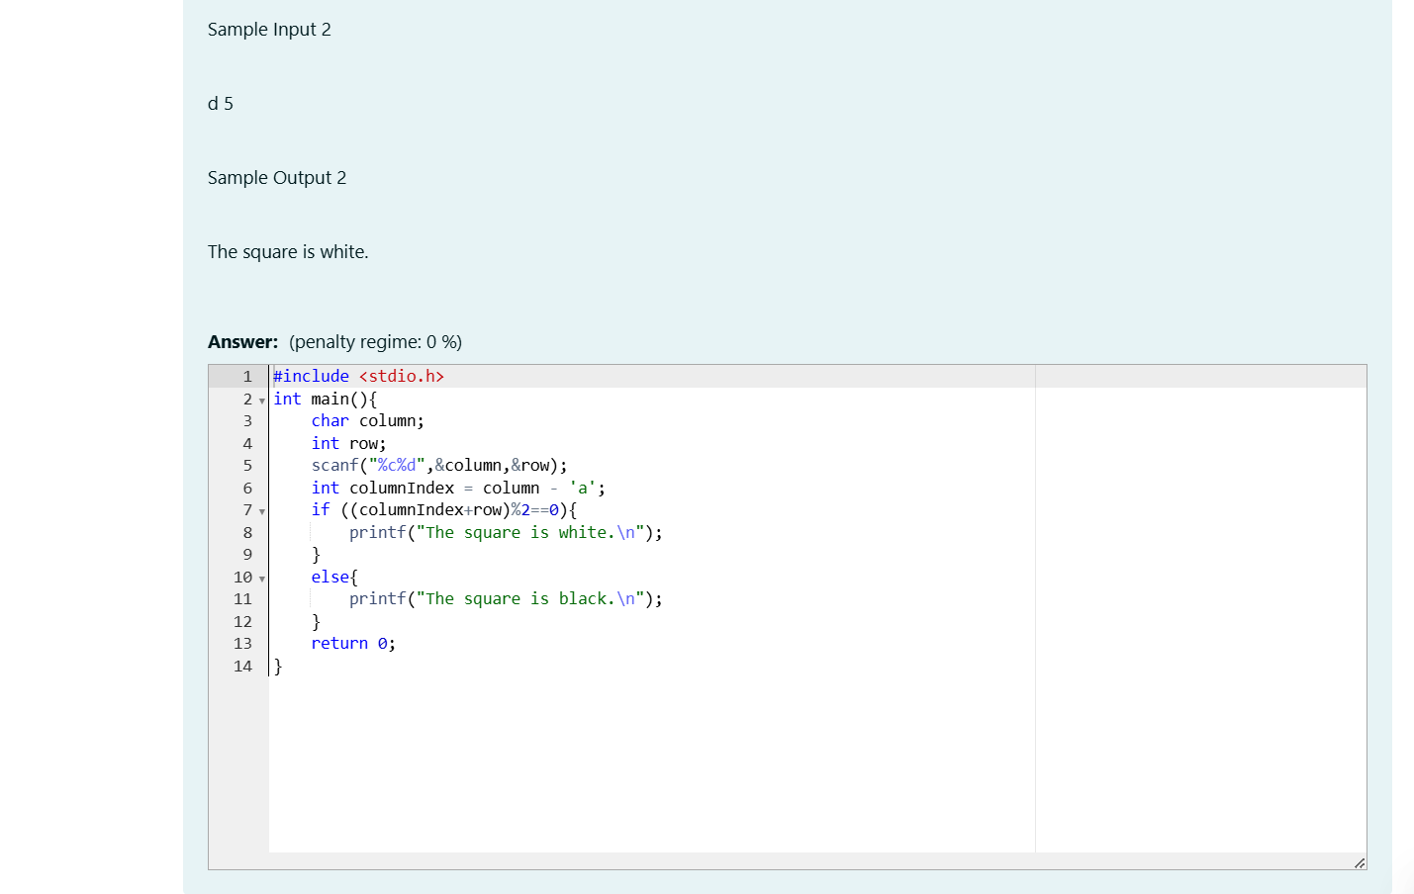

**OUTPUT:**

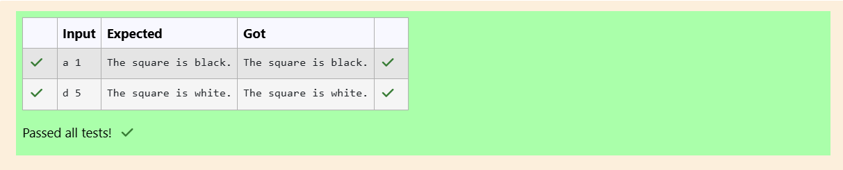

**Week 03-03**

**Roll no: 241801326**

**Name: Yogeetha A**



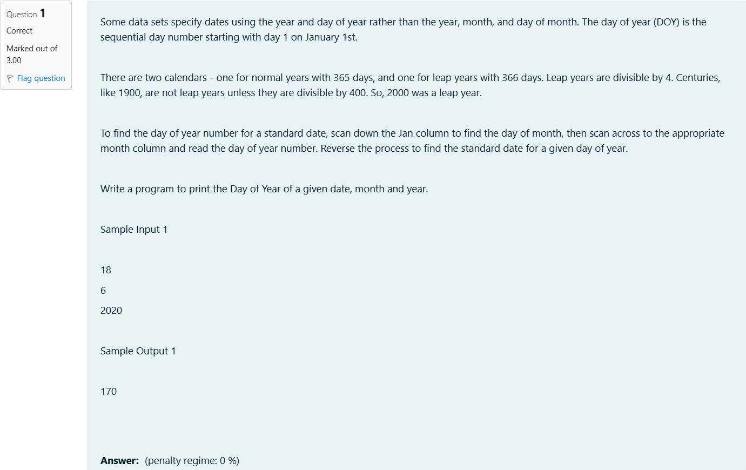

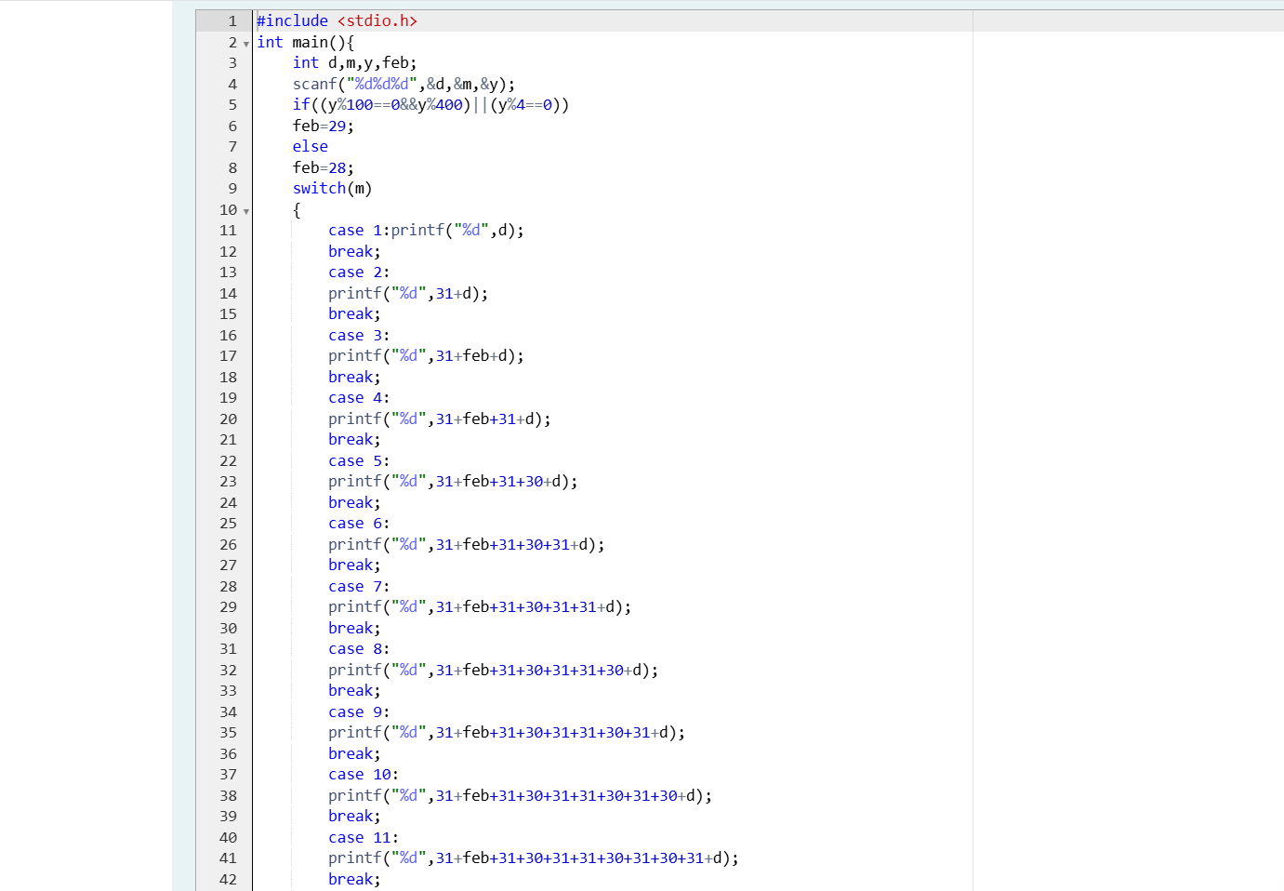



**OUTPUT:**

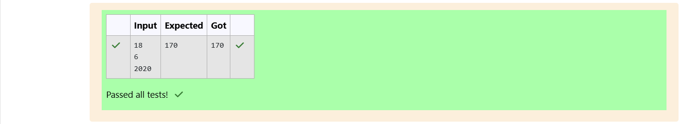

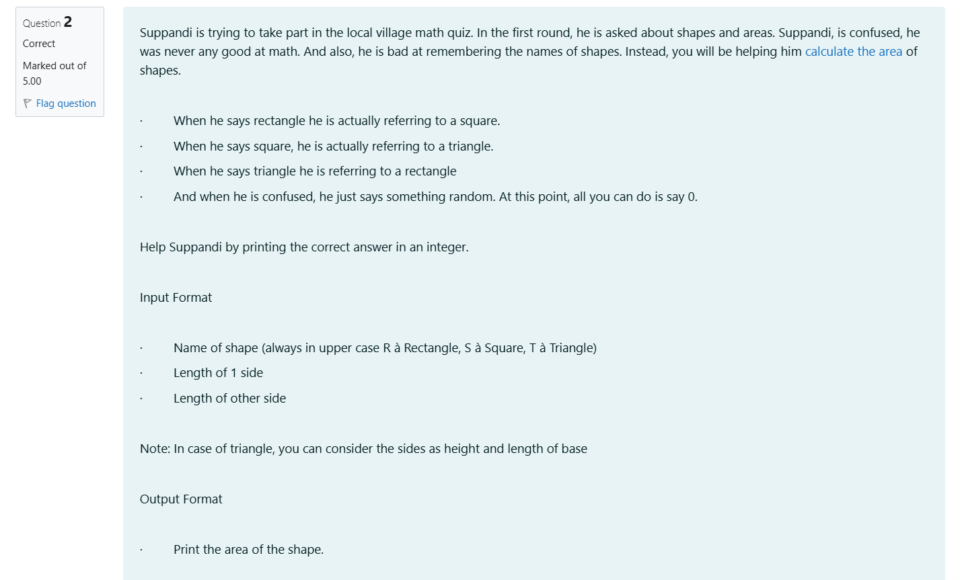

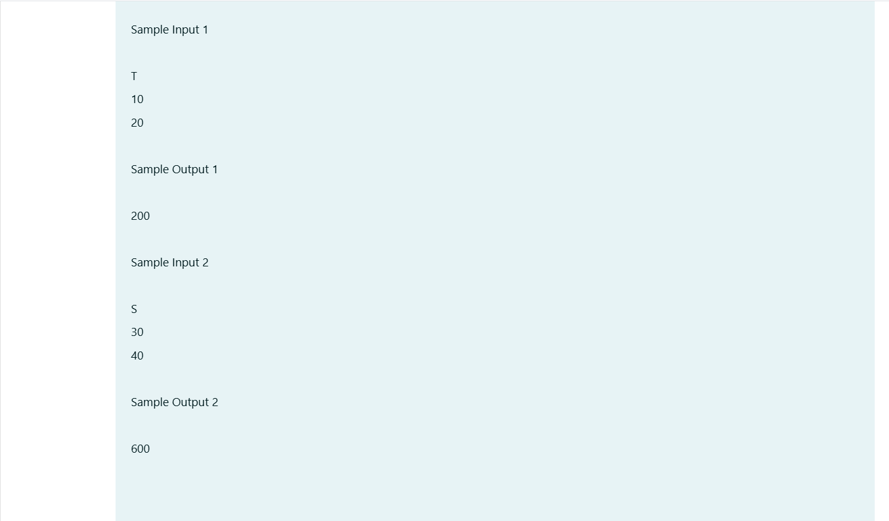

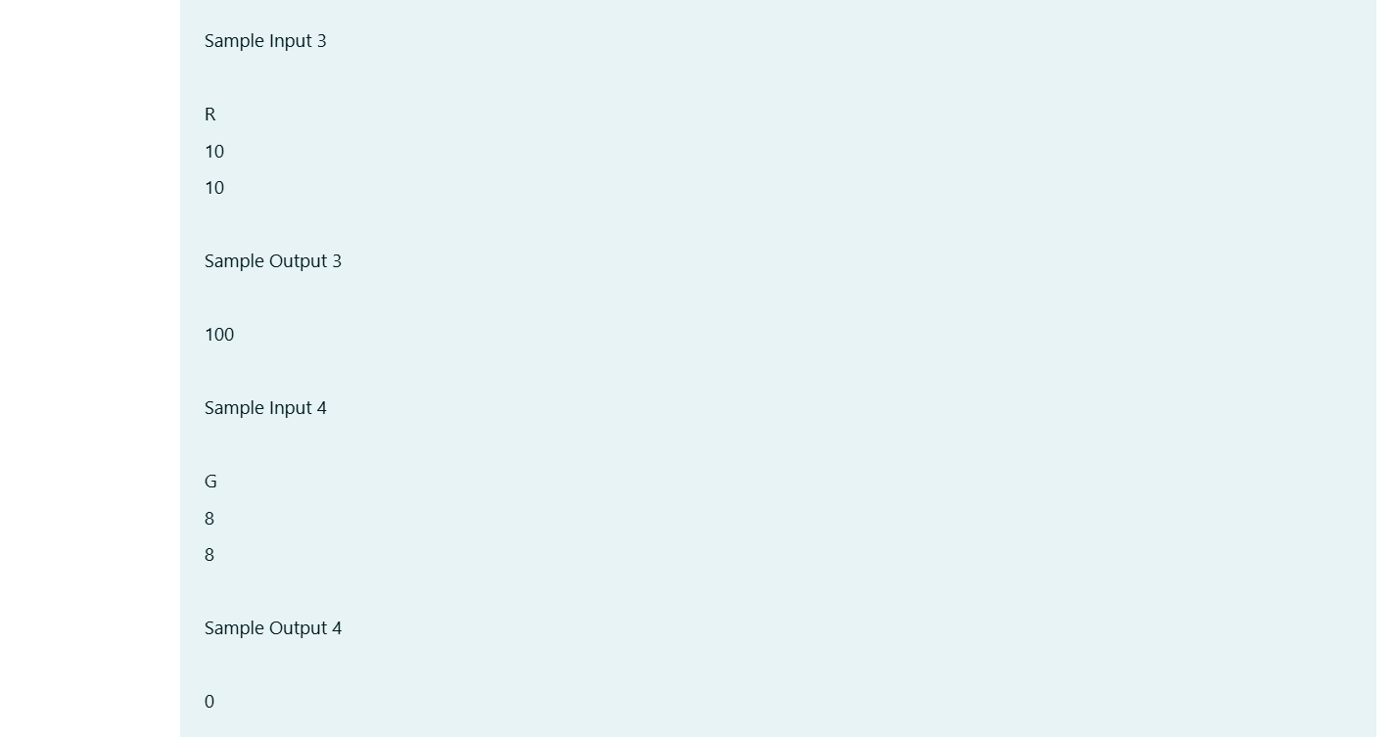

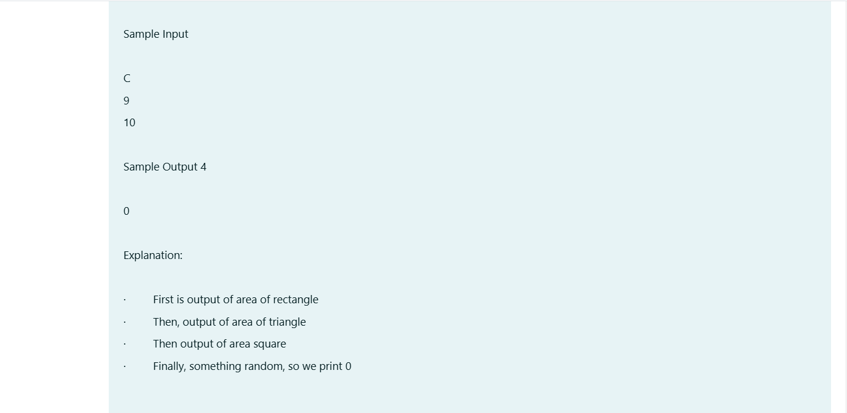

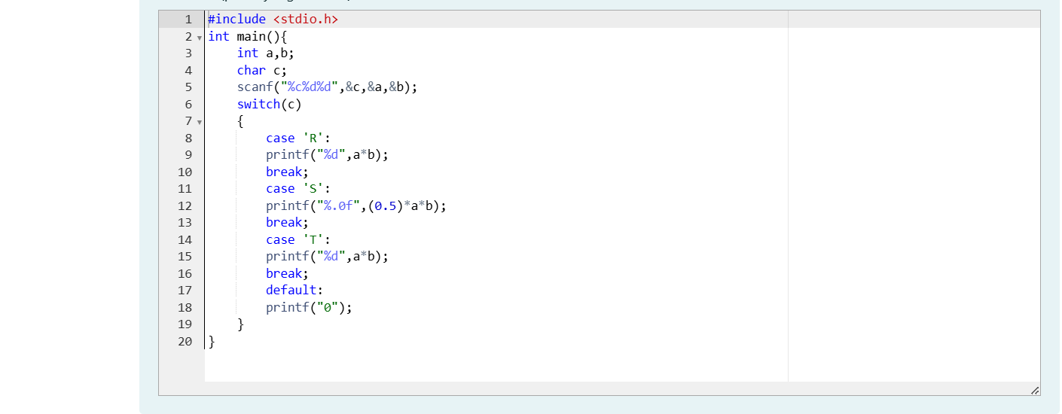

**OUTPUT:**

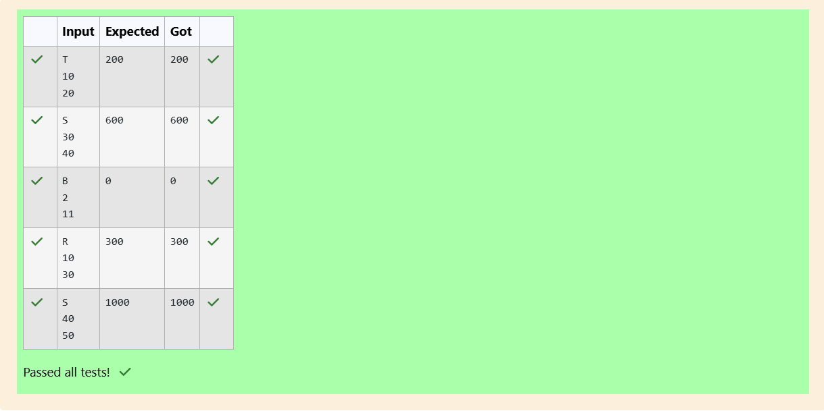

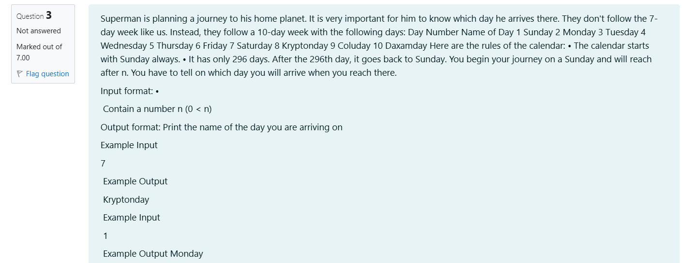

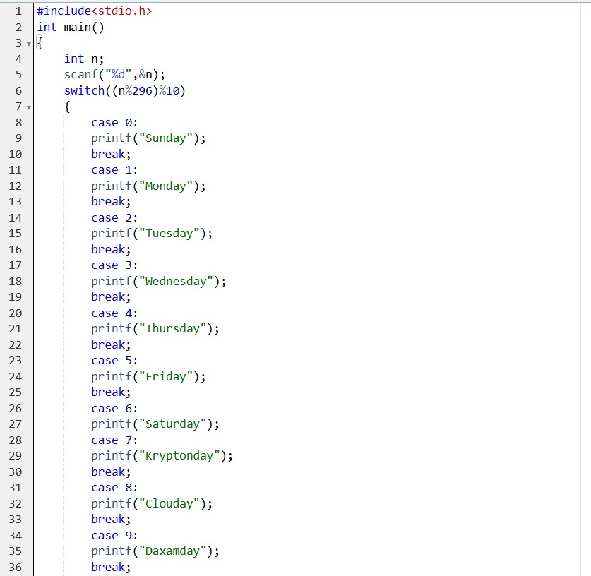

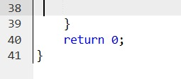

**OUTPUT:**

